**Ex. No. : 3 Date: 9/9/2025**



**Register No.: 231701039 Name: Prasanna R**

2D Transformations – Translation, Scaling, and Rotation

AIM:

To write a program that performs:

* Translation
* Scaling
* Rotation

on basic 2D shapes (e.g., triangle, rectangle) using transformation matrices.

# Procedure:

1. Define the 2D shape using its vertices.
2. Use matrix multiplication to perform:
   * **Translation** by adding offsets to coordinates.
   * **Scaling** by multiplying coordinates with scale factors.
   * **Rotation** by applying rotation matrix.
3. Display original and transformed shapes.

***Program:***

import numpy as np

import matplotlib.pyplot as plt

def draw_shape(points, label, color): x, y = zip(*points)

x += (x[0],)

y += (y[0],)

plt.plot(x, y, color=color, label=label)

.

def translate(points, tx, ty): T = np.array([[1, 0, tx],



[0, 1, ty],

[0, 0, 1]])

return apply_transform(points, T)

def scale(points, sx, sy): S = np.array([[sx, 0, 0],

[0, sy, 0],

[0, 0, 1]])

return apply_transform(points, S)

def rotate(points, angle_deg): angle_rad = np.radians(angle_deg)

R = np.array([[np.cos(angle_rad), -np.sin(angle_rad), 0], [np.sin(angle_rad), np.cos(angle_rad), 0],

[0, 0, 1]])

return apply_transform(points, R)

def apply_transform(points, matrix): transformed = []

for x, y in points:

vec = np.array([x, y, 1]) result = matrix @ vec

transformed.append((result[0], result[1])) return transformed

# Original triangle

triangle = [(0, 0), (100, 0), (50, 80)]

# Transformations

.

translated = translate(triangle, 120, 50)



scaled = scale(triangle, 1.5, 1.5) rotated = rotate(triangle, 45)

# Plot plt.figure(figsize=(8, 8))

draw_shape(triangle, "Original", 'blue') draw_shape(translated, "Translated", 'green') draw_shape(scaled, "Scaled", 'orange') draw_shape(rotated, "Rotated", 'red')

plt.title("2D Transformations") plt.legend()

plt.grid(True) plt.axis("equal") plt.show()

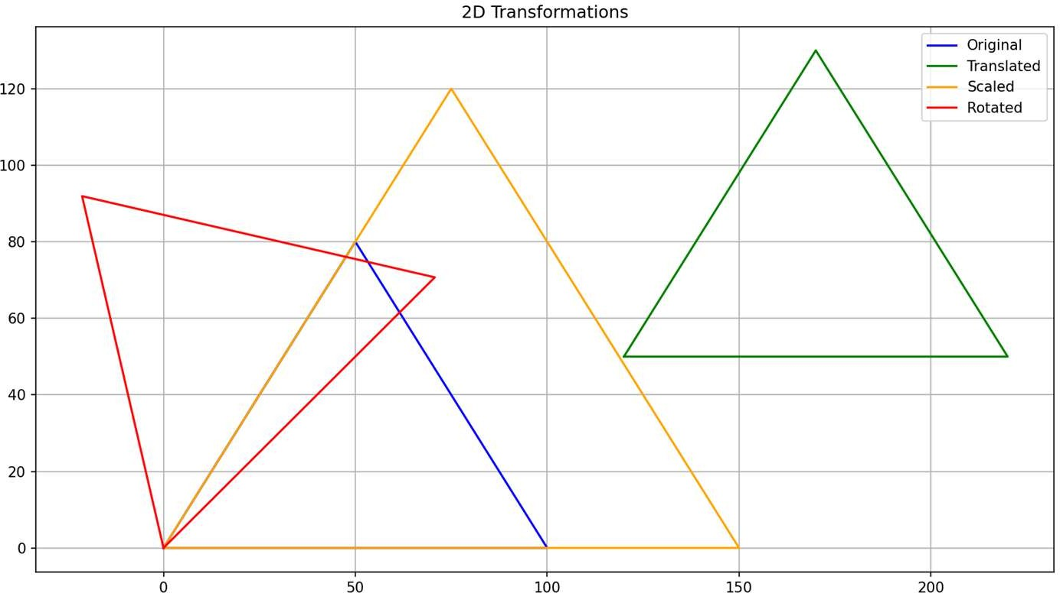

# Result:

The 2D transformations (translation, scaling, and rotation) were successfully applied using matrix operations on a triangle.

.